# System Manual

Getting start:

This manual will get you a copy of the project and running on your local machine for development and testing purposes.

To amend or extend the code, you need to have **Python** in your computer with at least **version 2.7**. And **MySQL** should also be installed in your computer as well to store the necessary data that needed in the QA system. A **Django** framework is not necessary for you to download to run this system since all required files are included in the folder.

Then an installing and running instruction will be introduced to tell you how to get start with this project:

* First clone <https://github.com/xiaofengF/Final-year-project>, then navigate to the …/Final-year-project/TripAdvisor/
* Then run **python manage.py runserver** on your terminal
* Then open localhost: **http://127.0.0.1:8000/**

It is the initial step for you to run this project, but the QA system will get error when you try to get an answer from the system since you haven’t initialized your database.

To initialize your database, you need to open the r**estaurants_crawler.py** and change the information in the code below:



* You must change the username and the password to your own one.
* Then you need to run **python restaurants_crawler.py** on your terminal. Then the code will collect all restaurants information from the website of TripAdvisor. This process may take you around several hours.
* Then you need to change all username and password in parser.py to your own one.
* Then you need to create your own question_types database like the format below.
  + (target 1, description, query terms)
  + (target 2, list, query terms)
  + (target 3, location, query terms)
  + (target 4, yes/no, query terms)
  + (target 5, detail, query terms)

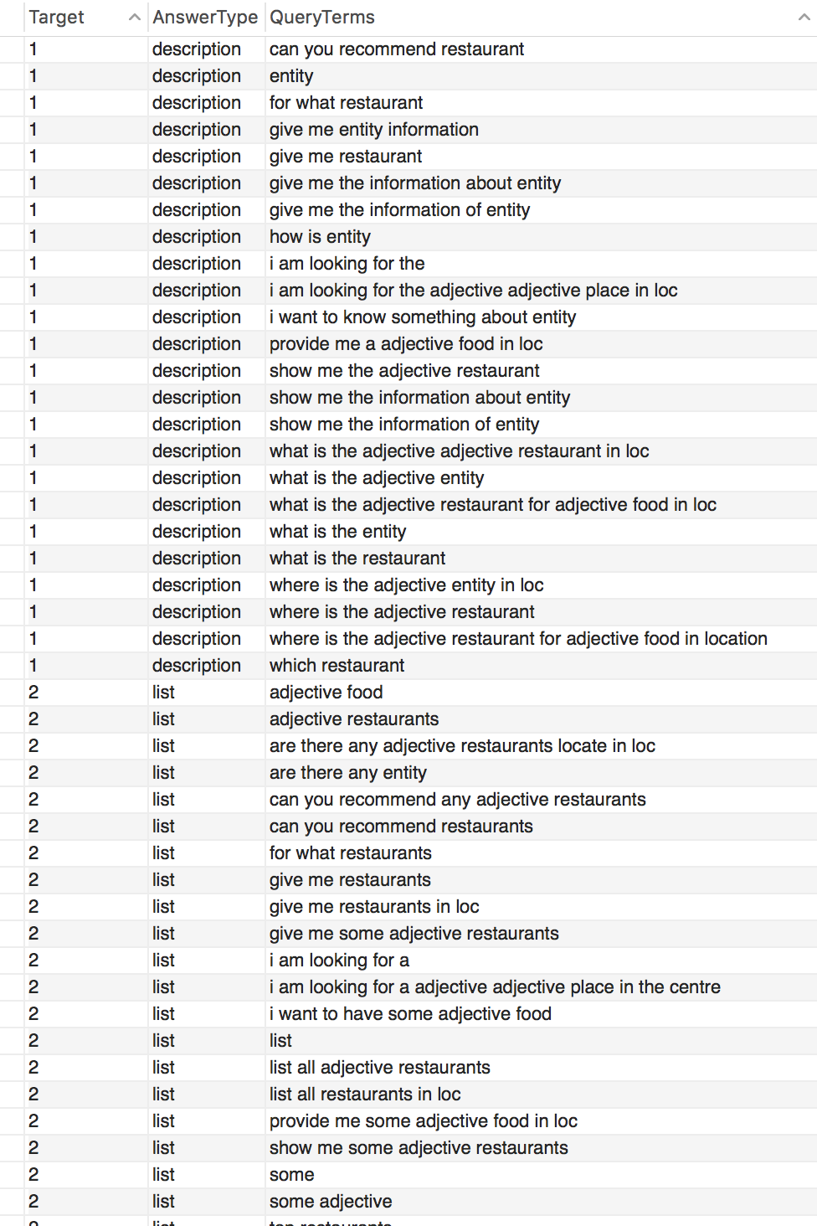

Code Structure

The code structure and the introduction of the files are shown below:

README.md

**restaurants_crawler.py**

TripAdvisor

* Manage.py (It is the file for the terminal to run the Django project. Don’t change it!)
* TripAdvisor
  + __init__.py
  + settings.py
  + urls.py
  + wsgi.py
  + **address.txt** (This file is used for the NLG system to generate a natural language txt of address)
  + **feature.txt** (This file is used for the NLG system to generate a natural language txt of feature)
  + **phone.txt** (This file is used for the NLG system to generate a natural language txt of phone)
  + **price.txt** (This file is used for the NLG system to generate a natural language txt of price)
  + **rank.txt** (This file is used for the NLG system to generate a natural language txt of rank)
  + **view.py** (This file is used to manage the form posted from the HTML page and it is the interim system to control the NLG system and the NLP system)
  + **nlg.py** (This is the source code of the NLG system)
  + **parser.py** (This is the source code of the NLP system)
  + **unit_test.py** (This file is used to test the functionality of the QA system)
* db.sqlite3
* templates
  + **index.html** (This is the graphic user interface of the QA system)
* Model